INFO5995 Assignment 1
Task 3、4部分
Task3:
- Keyword Static Analysis Table
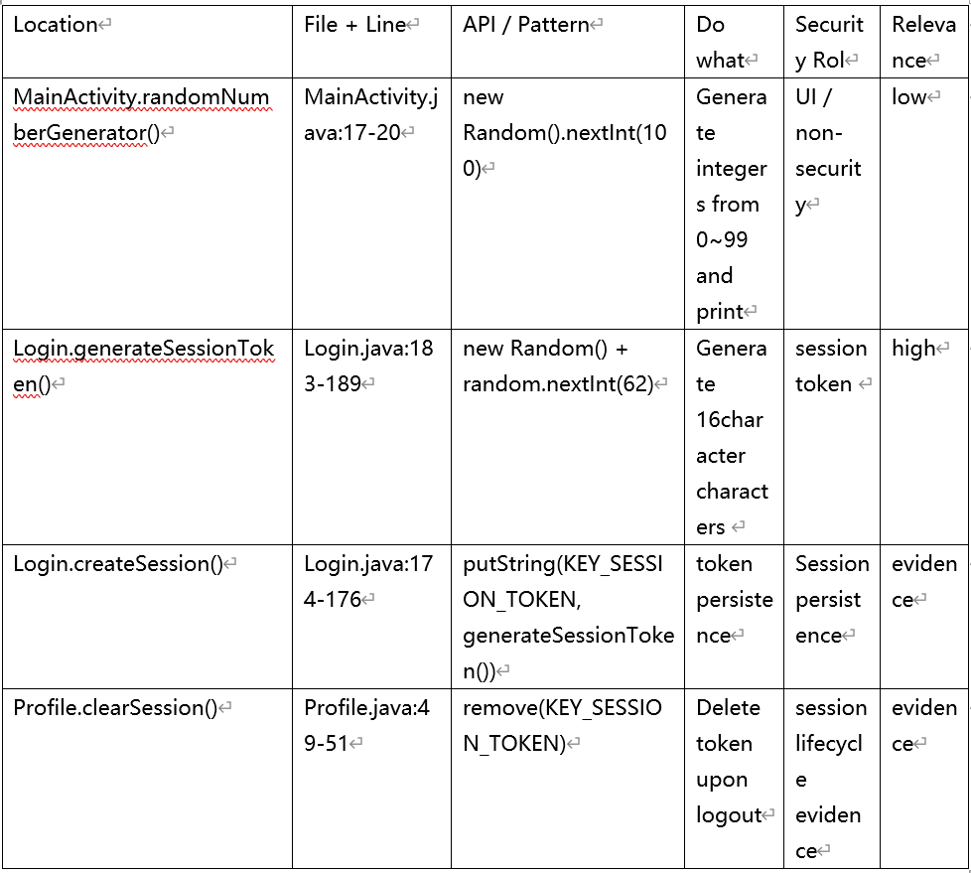

- Random Keyword Analysis (Potential Vulnerability)
  - File: MainActivity.java` Line:17-20
This code uses the insecure PRNG java.util.Random and generates an integer between 0 and 99 using `nextInt(100)`, prints it to the log, and then returns it. From a security perspective, this poses a risk of information leakage. However, since this random value is not used for authentication, session establishment, etc., it should be recorded as a vulnerability, but not a core vulnerability.

2.2 File: Login.java Line:183-189
This method creates a `java.util.Random` object, loops 16 times, and each time selects a character from uppercase and lowercase letters and numbers using `random.nextInt(62)`, ultimately concatenating them into a 16-bit session token. Using `java.util.Random` to generate a session token is insecure. `Random` is a general-purpose pseudo-random number generator, not a cryptographically secure random number generator (CSPRNG) designed for security scenarios. It cannot provide the unpredictability required for secure tokens. Therefore, this allows attackers to predict the token and hijack the session.

In the code, `createSession()` writes the generated token to `SharedPreferences`, and `getSessionToken()` reads this token again. This means that the generated value acts as a **session identifier/login status marker** in the application, thus affecting authentication/session state. Therefore, this is the most critical vulnerability.

Task4:
4.1 Vulnerability Location and Root Cause
**File:** `Login.java` **Line Numbers:** 183-189
The developer used `java.util.Random` to generate the value that would later be used as a session token. `java.util.Random` is designed for general random use, not for security scenarios against attackers; therefore, it lacks cryptographic unpredictability. Therefore, `generateSessionToken()` is unsuitable for its security role and should be replaced with `SecureRandom`.

4.2 Attacker Model
4.2.1 Who is the attacker? Attackers could be researchers testing application security, malicious users, etc.

4.2.2 What capabilities does an attacker possess?
1. Ability to obtain and decompile the APK: This allows them to see the implementation of `Login.generateSessionToken()`.
2. Knowledge of token generation rules, such as uppercase and lowercase letters + numbers.

3. Ability to observe application login behavior, such as when a user logs in, when a session is created after login, and whether the token is stored locally.

4.2.3 What knowledge does an attacker need?
An attacker only needs to obtain and decompile the APK, understand the session token's generation location, length, character set, random number generation method, and how it is stored and used for login status determination within the application. Combined with observation of the login process, this provides the basic conditions for exploiting this vulnerability to predict, forge, or replace tokens.

4.3 Step-by-Step Attack Scenario
Attack Scenario: Predicting/Forging Session Tokens Leading to Identity Impersonation
1. The attacker obtains and decompiles the APK, locating `Login.generateSessionToken()`, confirming that the application uses `java.util.Random` to generate a 16-bit session token.

2. The attacker analyzes the token generation rules, understanding its character set, length, and generation method, and confirms that the token is saved and used to represent login status.
3. The attacker observes user login behavior or local state changes to understand when the token is generated and saved, thus helping to deduce its generation process.
4. The attacker attempts to guess, forge, replace, or replay the token, exploiting the application's trust in the token to launch an attack.
5. If the application accepts the illegitimate token, the attacker may bypass authentication or impersonate a logged-in user.

